

Hackathon Registration Form

Instructions to the participants:
- Download this form from the File Menu
- Fill it and upload

Name of the Team | SPROUT STACK

Team member’s details:

Team | Member-1  (Team Leader) | Member-2 | Member-3 | Member-4
Member Name | VK SHRIDHARAN
Gender | MALE | MALE | MALE | MALE
Date of Birth | 26.04.2005
College Name with Full Address | VIT, Vellore Campus, Tiruvalam Rd, Katpadi, Vellore, Tamil Nadu 632014 | VIT, Vellore Campus, Tiruvalam Rd, Katpadi, Vellore, Tamil Nadu 632014 | VIT, Vellore Campus, Tiruvalam Rd, Katpadi, Vellore, Tamil Nadu 632014 | VIT, Vellore Campus, Tiruvalam Rd, Katpadi, Vellore, Tamil Nadu 632014
Current Year of Study | 3rd year
Course/Degree Name  (B.Tech/M.Tech/ B.C.A/M.C.A/ B.Sc./M.Sc./Others) | B.Tech CSE Core
Email ID | shridharan.vk2023@vitstudent.ac.in
Mobile Number | 7550249333
Any Previous Experience (Projects/ Hackathons/ Hands-on events, etc.) | Had attended technical fest coding challenge.

Paste your College ID Card (two sides)
(Participants must bring their College ID Card)
Member-1  (Team Leader) | 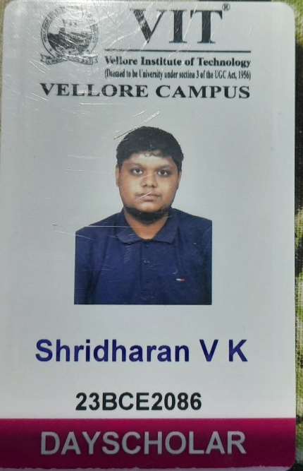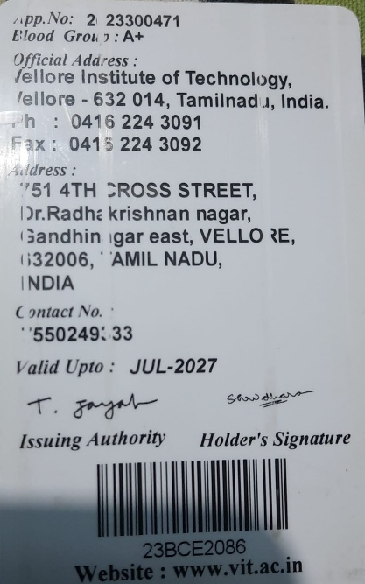
Member-2
Member-3
Member-4

